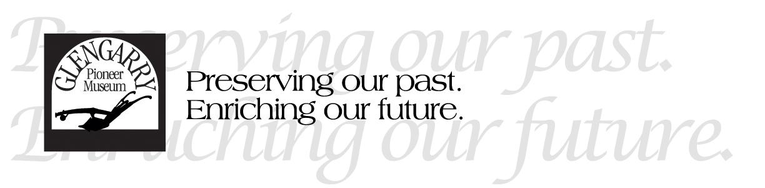
Position: Museum Interpreter
Under the daily supervision of the Curator/Administrator the Museum Interpreter will:
TASKS AND RESPONSIBILITIES:
- Assist the Curator in setting up eight museum buildings and exhibits before opening for the season. This includes unpacking artifacts and updating signage.

- Attend the Guest Services desk and be a frontline staff to greet visitors, answer questions, sell gift shop items, and take admission and donations while providing exceptional customer service. The Interpreter will convey historic information about the site, as well as offer either a self-guided tour or special guided tours. This may include seniors, families, children, organizations, persons with disabilities, or people of either official language. Due to our proximity to Quebec and large Franco-Ontarian population, this often includes communication in French.

- Work collaboratively with other staff and volunteers to host school field trips in June. This will involve leading a station with one volunteer, interpreting a theme and leading a hands-on activity to support it.

- Assist event planning committees with the creation of children’s activities themed for each event. This may involve selecting activities and crafts that have been done in the past, or creating something new. This will involve planning, setup and implementation. It may also involve leading other volunteers and/or staff in the activities.

- Undergo a project to record bilingual audio content that will be accessible by QR code in three of the museum’s historic buildings.

- Share in the daily operational duties of opening, closing, communicating with the public and an increased cleaning regime to be followed by all staff.

