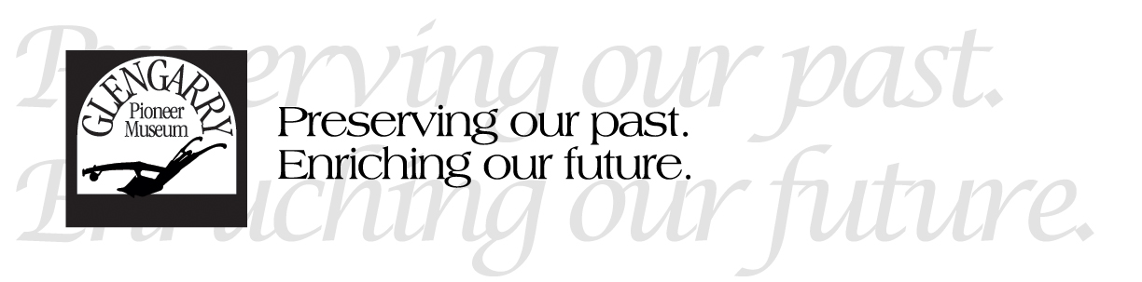
Position: Events Coordinator and Administrative Assistant
Under the daily supervision of the Curator/Administrator, the Events Coordinator and Administrative Assistant will:
TASKS AND RESPONSIBILITIES:
- Act as a liaison with event planning committees to determine what they need from museum staff to prepare for their special events and ensure those needs are met. This will likely involve managing pre-registration initiatives, recruiting volunteers, securing necessary permissions from health authorities and arranging for necessary permits.

- Take a lead role in a small team to plan and implement an outdoor, volunteer appreciation BBQ scheduled for early August. This will involve sending invitations, planning a menu, and a schedule of activities (e.g. speeches, trivia, games, etc.)

- Prepare weekly finances for transfer to the Treasurer. This includes tallying admission, donations, memberships, gift shop sales, etc. Monitor the gift shop inventory to ensure it is updating correctly.

- Make monthly updates to the museum’s website to ensure event information is up-to-date and easy to find from the home page. Research other museum websites and make suggestions for improvements to our own.

- Share what staff are working on behind-the-scenes via Social Media at least once per week. This could include short video clips of staff showing an artifact they are working on, or a photograph with short description.

- Improve the museum’s online profile by updating the museum’s information on various tourism websites such as TripAdvisor, Ontario Travel sites, etc.

- Share in the daily operational duties of opening, closing, communicating with the public and an increased cleaning regime to be followed by all staff. As an official language minority community, there is often opportunities to speak French.

