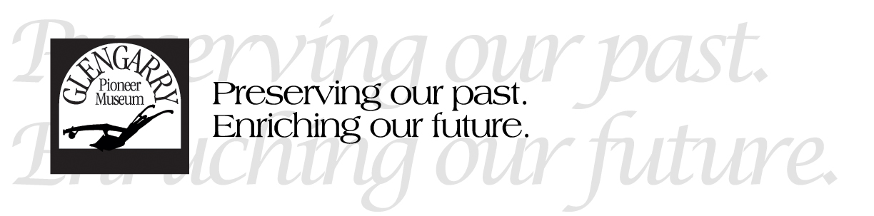
Position: Collections and Research Assistant

Under the supervision and guidance of the Curator/Administrator the Collections and Research Assistant will:
TASKS AND RESPONSIBILITIES:
- Undergo an inventory of artifacts, starting with items in the kitchen space. This will include photographing, documentation, condition reports and often research to add to the sometimes-basic records. Maintaining the collection in this way is one of the key roles of a museum. The Curator/Administrator will assign 10 artifacts per week and adjust numbers as necessary.

- Prepare and manage a weekly “Featured Artifact” blog that will be posted on social media and linked to the museum’s website. This will ensure that the museum reaches a wider audience and educates the public on what the museum cares for and the history of what is held in trust for this community. This could be based on a theme such as “Transcription Tuesday” which transcribes handwritten archival content such as letters. Alternatively, it could be a “What is it?” theme looking at unusual artifacts from the collection.

- Learn basic conservation skills and undergo the cleaning of select tools in the collection, at least one day per week.

- Using the archive of past “Featured Artifact” series, schedule artifact related social media posts once per month starting in October and going until spring.

- Assist the Curator in cataloguing new donations.

- Share in the daily operational duties of opening, closing, communicating with the public, taking admission and other tasks as necessary. This may involve interacting with seniors, families, children, organizations, disabled persons, and people of either official language. Due to our proximity to Quebec and a large Franco-Ontarian population, this often includes communication in French.

